
MANAGING DETAILED WPM REPORTS IN COURSE MANAGER

Detailed WPM Table/Chart Report Overview 1
Include results from: Student, Campus, Class 2
Include the “x” best timings per segment 2
Include timings with “x” or fewer errors 2
Include timings from 2
Segment filters 3
Detailed WPM Report Steps: 3
Exporting and Sorting the Detailed WPM Table Report to Excel 9
To export the Detailed WPM Table Report to Excel: 9
To sort the Detailed WPM Table Report in Excel: 9
Using the Detailed WPM Chart Report 9
To use the Detailed WPM Chart Report for a single student: 10

Note! The screen shots in this handout in some cases represent Classes and Sections in which the Interim Gradebook is enabled and in use. If you do not have a Gradebook enabled, your views and some features will vary. The enabling or disabling of Messaging, Resources, Formatting Assistant, Hide Format Scoring from Student, Score Keystroking, and Proofreading Viewer also affects the appearance of GDP screens:

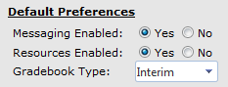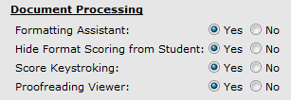

This handout will help you use the Detailed WPM Table Report and the Detailed WPM Chart Report from the Reports tab in Course Manager to see Timed Writing results in a Class Section for individual students or for a Campus, Class, or Section. See Course Manager Tips for more helpful information using Course Manager in general and for specific tips on the Student Portfolio report.

Detailed WPM Table/Chart Report Overview
The Student Portfolio provides access to all timed writing results and can be filtered by Timed Writing type, lesson and date range, duration, and so forth. However, it cannot filter to the best timed writings results based on a given speed and error tolerance, and it cannot filter for results from an entire Class or an entire Class Section. This can be accomplished via the Detailed WPM Table Report. The Chart Report will display the same results, but in a bar chart format.

The Detailed WPM Table report:

- Generates a listing, for example, of all timed writings or only the best timed writings for a given student, Campus, Class, Section, or multiple Classes and Sections.
- Includes columns for WPM and Errors—you can view all results simultaneously.
- Is useful at the end of a school term when you need easy access to all timed writing results data for the school term for each student, which you can filter specifically in order to return an automatic WPM average final grade for timed writings that reflects your course standards for a selected student.

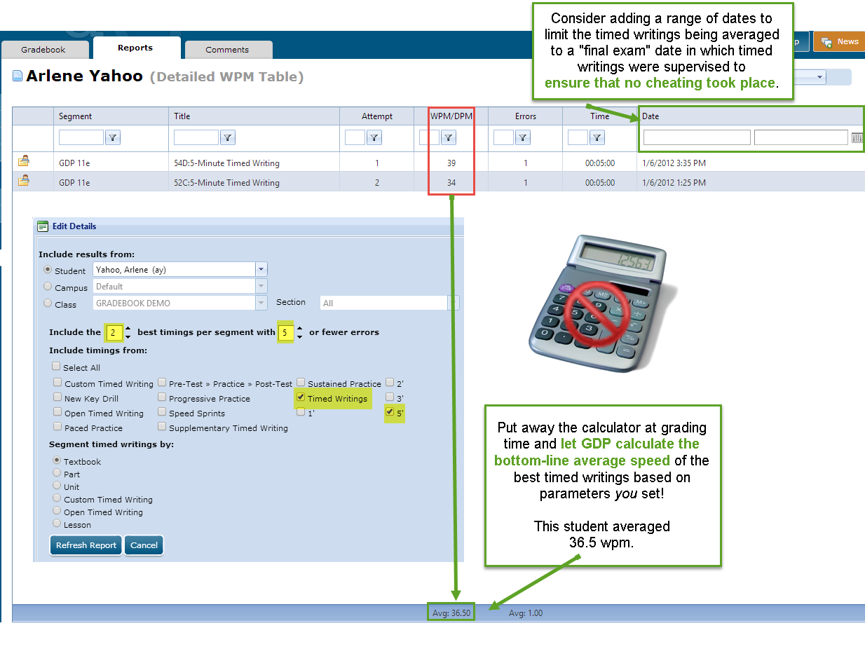

Include results from: Student, Campus, Class
The first choice you must make is elect to see results for an individual student, an entire Campus, a Class (meaning all Sections of that Class), or one Section of a Class.

Include the “x” best timings per segment
Next, you must decide how many “best” timings you want to see per segment. Generally speaking, if you are using the report to help you assign a final grade in the category of timed writings, your choice here should match your course standards and guidelines. You can set limits as high as 99—the higher the number, the broader the results.

Include timings with “x” or fewer errors
Next, you must decide how many “maximum” errors you want to filter for. Generally speaking, if you are using the report to help you assign a final grade in the category of timed writings, your choice here should match your course standards and guidelines. You can set limits as high as 99—the higher the number, the broader the results.

Include timings from
Next, you must decide which timing category to include and whether you also wish to filter by timed writing duration of 1, 2, 3, or 5 minutes. Here are your choices:
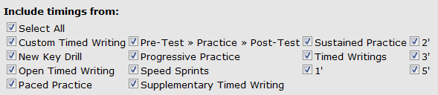

This table will help you remember which timed writing lengths are available for each timed writing category so you can set duration filters that will achieve your desired result:

CATEGORY | TIMED WRITING DURATION
CATEGORY | 12" | 30" | 1' | 2' | 3' | 5'
Custom Timed Writing |  |  | x | x | x | x
New Key Drill | NA | NA | NA | NA | NA | NA
Open Timed Writing |  |  | x | x | x | x
Paced Practice |  |  | Pretest | x
Pre-Test, Practice, Post-Test |  |  | Pretest/Posttest
Progressive Practice |  | x
Speed Sprints | x
Supplementary Timed Writings |  |  |  |  | x | x
Sustained Practice |  |  | x
Timed Writings |  |  | x | x | x | x

Uncheck Select All to clear all boxes, and then check off your desired category choices. When you check Timed Writings, the sub-filters for the timed writing duration of 1', 2', 3', or 5' appear. To include one or more of the timed writing durations as a sub-filter for other categories, then also check any other desired categories to be included. If a 5' timed writing exercise in the text has been taken as a 3' timing, the results will be reported by checking the 3' filter.

Note: To include Custom Timed Writing or Open Timed Writing results along with any of the other Include timing from segments, click their respective checkboxes and any other desired checkboxes in that section. Then click either Part, Unit, or Lesson—All under Segment timed writings by. However, if you want to view only Custom Timed Writing or Open Timed Writing results, under Segment timed writings by, click either the Custom Timed Writing or the Open Timed Writing radio button. Note that when you click one of those radio buttons, any selected checkboxes are cleared in the Include timing from section.

Segment filters
It’s very important to understand the effects of choosing a segment filter so you end up with the desired timed writings results. To keep the examples simple, you can assume that I’ve set previous choices to include “2” best timings for 1 student per segment. Here’s what each segment will return under those conditions:

- Textbook segment: Returns the 2 best timings in the entire textbook, which includes Lessons 1-120.
- Part segment: Returns the 2 best timings in each of 6 parts, potentially 12 timings total.
- Unit segment: Returns the 2 best timings in each of 24 units, potentially 48 timings total.
- Lesson—All segment: Returns the same results as Textbook segment. The two best timings taken over the range of 120 lessons will be returned.
- Lesson—Part segment: Part, which requires to you select a specific part, returns 2 results per student for that Part.
- Lesson—Unit & Tests segment: Unit & Tests, which requires to you select a specific unit or test, returns 2 results per student for that unit or test.
- Lesson—Lesson and Lesson “x” segment: Lesson “x” requires to you select a specific lesson, and returns 2 results per student for that lesson.

Detailed WPM Report Steps:
To see all results for all students on timed writings only, which appear at the end of Lessons 1-20 and even numbered lessons, as opposed to Custom Timed Writings, Paced Practice, and so forth), set the parameters as shown in the screen shot under step 8. Note that you might have to scroll horizontally to see all columns.

- Under USERS, click GPS, Reports tab.
- Click the Report Type list arrow, Detailed WPM Table.
- Click Include Results from Student (to view one student at a time), Campus (to view all students across the campus), or Class (select desired Class) and Section—All (to view one class and all sections), or Class (select desired Class) and Section (select desired Section) to view the desired Class and one specific Section of a Class.
- Enter the number of best timings to include per segment.
- Set the number of errors per timing to allow.
- To view only timed writings, uncheck Select All and check Timed Writings; if desired check 1', 2', 3', and or 5' to filter timed writings by duration.
- Check any other timed writing category. For example, to view only Supplementary Timed Writing results by length, uncheck Select All and check both Timed Writings and Supplementary Timed Writings; then check 1', 2', 3', and/or 5' sub-filters.

Note! When the 3' sub-filter is used, the filtered results are based on the duration of the timed writing, not the exercise name. For example, if a student selected a 3' time limit on a 5-Minute Timed Writing exercise (this 3' or 5' time limit option begins in Lesson 52), the results of that timed writing will be reported when the 3' sub-filter is used.
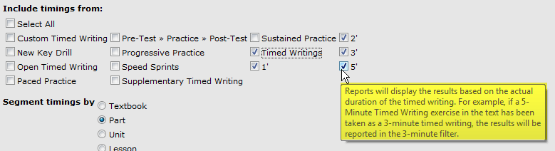

- Click Segment timings and choose either Textbook, Part, Unit, or Lesson (All, Part, Unit & Tests, or Lesson).
- Click View Report.
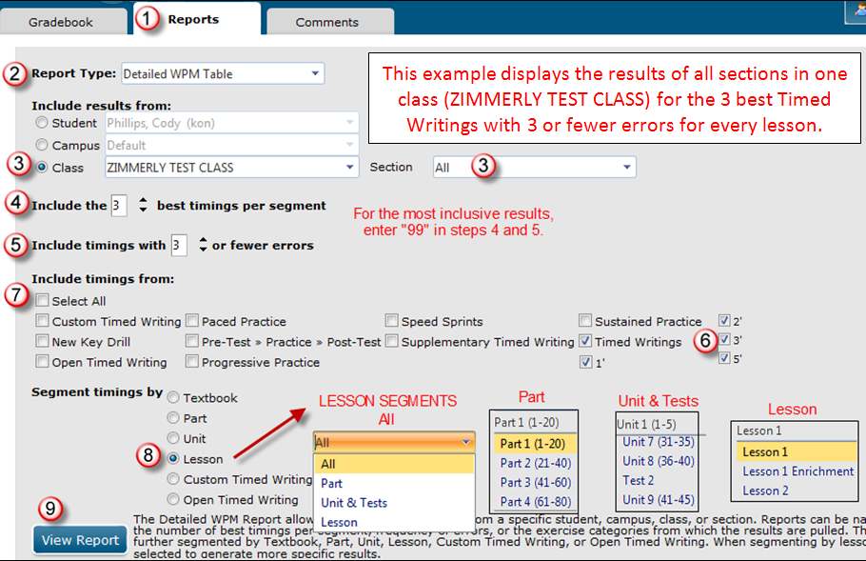

Examples for Segment timings by with 3 best timings per segment:
When you select a segment, you are defining what segment should be included when the filter is applied. For example, if you ask for 3 best timings per segment, you will receive 3 results per student per segment (provided the student has taken that many timings within the error limit). Here is a list of expected results when you ask for 3 best timings per segment and Segment timings by:

- Textbook: 3 best timings from the entire textbook (potentially 3 results per student).
- Part: 3 best timings from each of 6 Parts (potentially 18 results per student).
- Unit: 3 best timings from each of 24 Units (potentially 72 results per student).
- Lesson: filter by:

  - All: 3 best from all of Lessons 1-120 (potentially around 3 results per student).
Note: Lesson—All returns the same result as the Textbook segment.
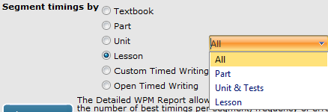

  - Part—Part 1: 3 best in each of Lessons 1-20 (potentially 60 results per student).
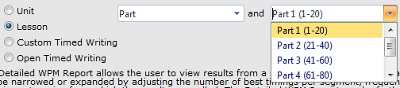

  - Units & Tests—Unit 1 (1-5): 3 best in each of Lessons 1-5 (potentially 15 results per student).
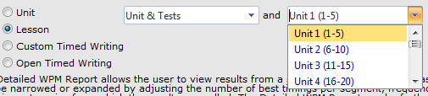

  - Lesson—Lesson 1: 3 best in Lesson 1 only (potentially 3 results per student).
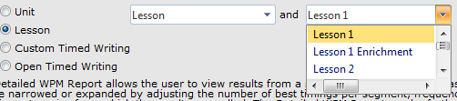

- Navigate through the results using the navigation buttons at the bottom or use the Action menu to Print, Export, or View Chart in Excel as desired. Scroll right to see Time and Date columns.
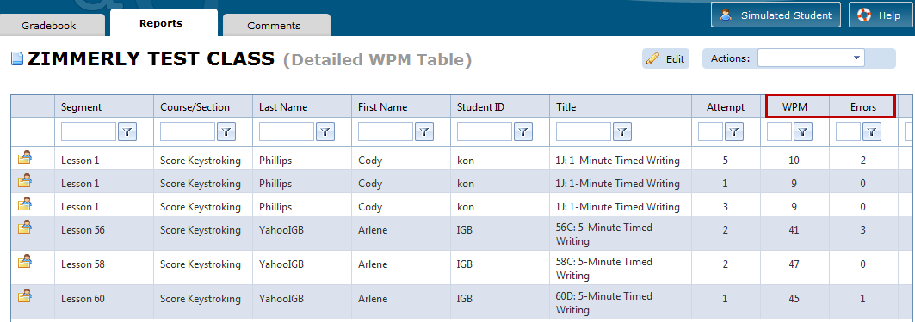
Click the Portfolio button to open the Student Portfolio for the desired student.

To change your export parameters, click the Edit button. In the Edit Details dialog box, change any parameters as desired; click Refresh Report. Consider this:

- Click the list arrow next to Include Results from Student to view a different student.
- Click the list arrow next to Class to view a different Class.
- Click the list arrow next to Section to view a different Section.
Note: Resetting parameters via the Edit button is preferable to clicking the Reports tab to move to the original screen. Using the Reports tab releases the parameters you just set.

Here are some more examples:

- This example includes results for one student (Arlene YahooIGB) for the Lesson—All Segment for the 3 best timings with 3 or fewer errors. Note the WPM and Errors columns are easily visible because Last Name, First Name, and Student ID are not needed.
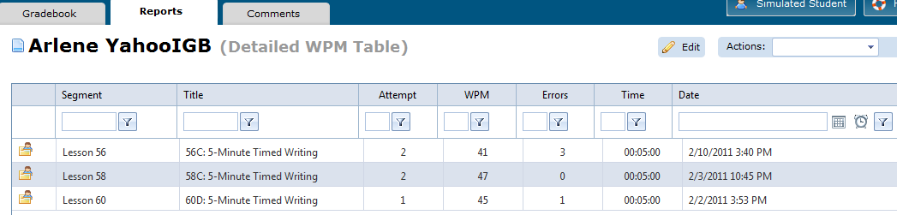
In this example, the original parameters were 99 best timings per segment and 99 or fewer errors, which returned 15 pages of results. Changing 99 to 3 is probably more desirable.
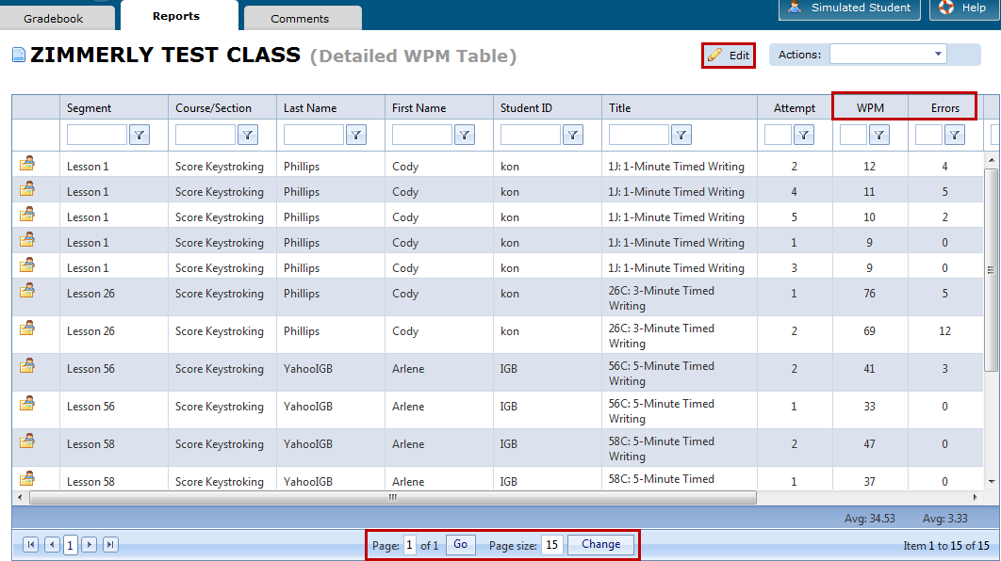

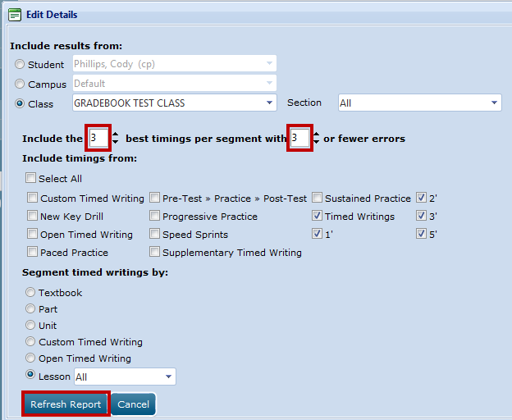

- This example includes results for all students in one Class (ZIMMERLY TEST CLASS) for the Lesson—All Segment for the 3 best timings with 3 or fewer errors. You must scroll to the right to see the Date column.
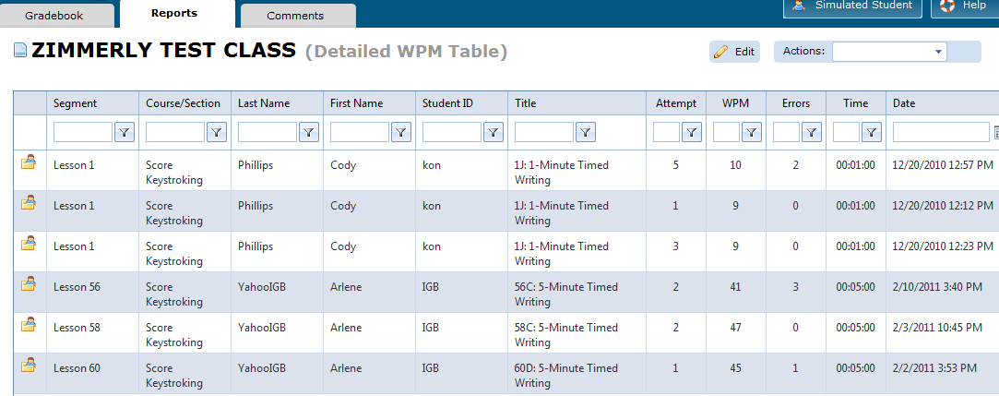
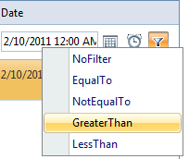
Tip: If, for example, you administered a timed writing test on a particular day and wish to view only test results for that day, scroll to the right and type a day in the Date box (or open the Calendar pop up and choose a date and a time); then click Greater Than to show all timings taken on that date from 12:00AM onward and click Filter.

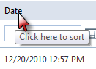
You could click on the Date column to sort by date. Remember, at any point, you can click the Edit icon and change any desired parameters—perhaps go back and change your sort from Class to Student and click Refresh Report to narrow your results to one particular student.

Exporting and Sorting the Detailed WPM Table Report to Excel
The Export feature allows you to export results to Excel. Excel includes powerful sort features.

To export the Detailed WPM Table Report to Excel:
- Follow steps under To use the Detailed WPM Report to display the report with the desired parameters.
- With the report displayed, from the Actions menu, click Export.
- Steps will vary depending upon your browser. Follow the prompts to Open or Save the Excel file.

To sort the Detailed WPM Table Report in Excel:
Excel provides many options for sorting this report. Consult an Excel reference for in-depth coverage. Column headings in the Excel file will vary depending upon the filters in use when the report was exported. Here is one example of some column headings that might display in Row 1 of the Excel file:
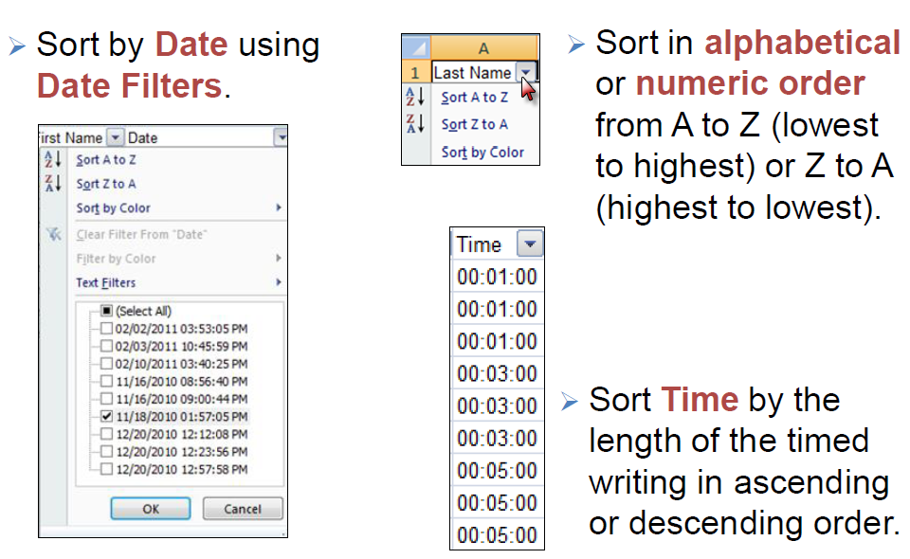

Using the Detailed WPM Chart Report
The Detailed WPM Chart report:

- Generates a bar chart of the average WPM results of the best timed writings for a given Student, Class, Section, or multiple Classes and Sections based on the Detailed WPM Table results.
- Is likely most useful if you wish to view the average best timed writing WPM for one student at time with each segment average calculated individually.
- Can be used to chart trends in a more understandable way.

To use the Detailed WPM Chart Report for a single student:
- Follow steps under To use the Detailed WPM Report to display the report with the desired parameters except:
  - Choose Detailed WPM Chart as the Report Type.
  - Set Include results from to Student.
- Enter the number of best timings to display per segment and the number of errors per timed writing to allow—higher numbers generate more inclusive results but are slower to display.
- Uncheck Select All and check Timed Writings (and any desired sub-filters for 1', 2', 3', and/or 5') to view only timed writings.
- Click Segment timings and choose either Textbook, Part, Unit, or Lesson (All, Part, Unit & Tests, or Lesson). This was the segment used in the next two examples: 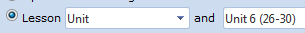
- Click View Report to display the Detailed WPM Chart.
- Note that the chart displays the Average WPM speed for that student on a given lesson. For example:

An Average WPM Speed of 63 is displayed in the Detailed WPM Chart for this student for Lesson 26.
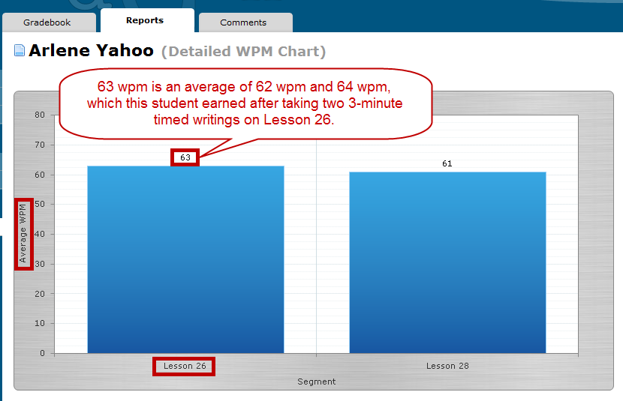

Note that the Detailed WPM Table reports the average WPM of 62.33 and the average errors of 1.67 for both lessons combined. Those averages may not have as much significance depending upon course requirements for a final grade in the category of timed writings.
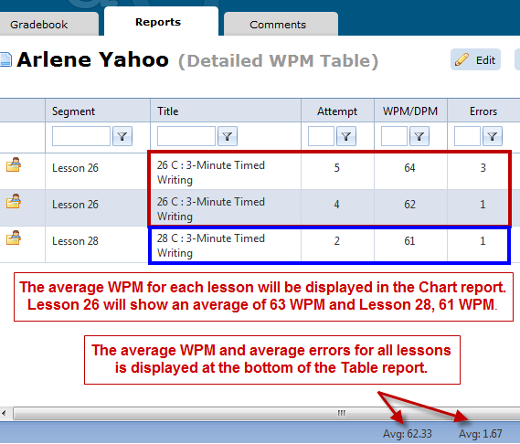

In this example, filters were set to display the averages for the 5 best timings with 5 for fewer errors for the Unit segment for this student. It’s easy to see the upward trend in Average WPM as this student increased her average speed in each unit from 40 to 61.
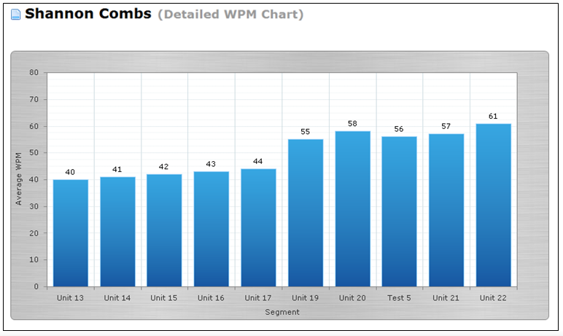

The Detailed WPM Table reports an average WPM for all units of 47.22 and with average errors of 1.11. Those averages, however, don’t have much significance when compared to the average WPM reported for each unit.

