
MESSAGE CENTER

MESSAGE CENTER—INSTRUCTOR 1
To enable or disable the Message Center: 1
To open the Message Center: 2
Inbox tab 2
Create tab 2
Drafts tab 3
Sent tab 3
To create and send a message to a Class: 3
To send a message from the Class tab: 3
To send a message from the Message Center, Create tab: 4
To create and send a message to a Section: 5
To create and send a message to a User (student): 6
To send a message from the Students tab: 6
To send a message from the Message Center, Create tab: 6
To clear Recipients: 7
MESSAGE CENTER—STUDENT 8
To open the Message Center: 8
Inbox 8
Draft 8
Sent 9
Refresh 9
Compose Message 9


Note! The screen shots in this handout in some cases represent Classes and Sections in which the Interim Gradebook is enabled and in use. If you do not have a Gradebook enabled, your views and some features will vary. The enabling or disabling of Messaging, Resources, Formatting Assistant, Hide Format Scoring from Student, Score Keystroking, and Proofreading Viewer also affects the appearance of GDP screens:

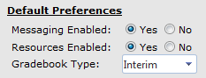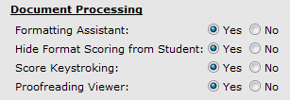

MESSAGE CENTER—INSTRUCTOR
In Course Manager, Messaging Enabled in Class/Section Preferences is the default; therefore, Message Center appears as an item in the USERS pane. When a new message arrives, instructors will see a number by Message Center in the USERS pane.

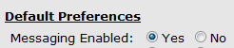
To enable or disable the Message Center:
- Click Classes; for the desired Class and Section, from the Actions menu, click Edit.
- From the Preferences tab, under Default Preferences, Messaging Enabled, click Yes (or No), Save.
- Note that a confirmation message, “Your changes have been saved.” appears at the bottom of the screen.
- Repeat if needed for the desired Section. Message Center should now appear (or disappear) as an item in the USERS pane.

To open the Message Center:

- From the USERS pane, click Message Center.
Or:
- From the Students tab, click the Actions menu, Send Message.
Note: If you are sending a message to an individual student, using the Actions menu, Send Message, from the Students tab for that student is seamless—when you use Message Center, Create tab, and click Add Recipient in the To User box, you’ll have to search for the desired student.

When you have mail, you will see: (1) a number by Message Center in the USERS pane and by Inbox, (2) a New icon on the Inbox tab, and (3) the new message link will display in bold.
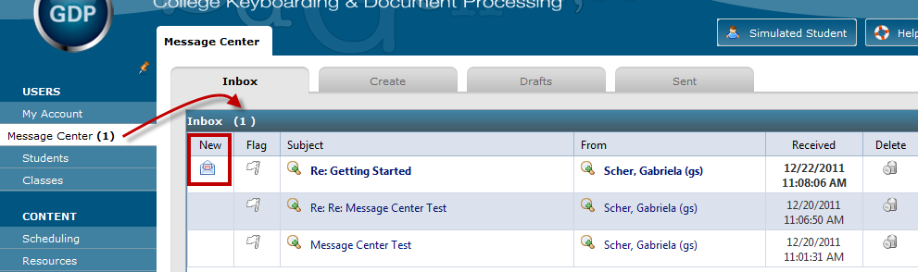

Inbox tab
Click the Flag to flag this item, click the message line to open and read the message, and click Delete to delete the message.
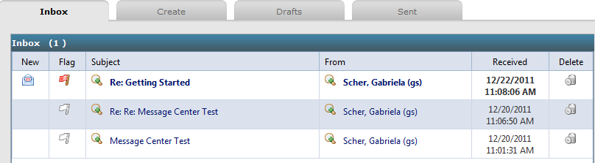

Create tab
Use the Create tab to send messages to a Class, Section, or User (student). See To create and send a message to a Class, To create and send a message to a Section, and To create and send a message to a User for details.

Drafts tab
Use the Drafts tab to review saved drafts of messages. Click Edit Message for the desired message to edit it. Click Delete to delete the draft.
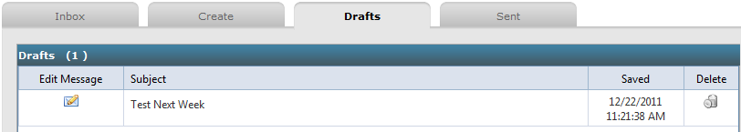

Sent tab
Use the Sent tab to review archives of saved messages. Click a Subject hyperlink to open the message. Click on click for recipient(s) to display recipients for that message.
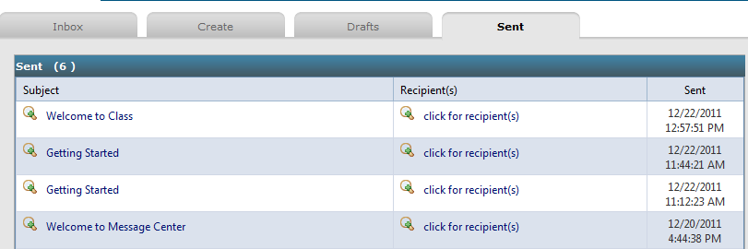

To create and send a message to a Class:
You can use the Message Center, Create tab, to broadcast a message to a Class; but you’ll need to search for the Class when you click Add Recipient from the To Class box. Using the Classes tab to broadcast a message to class is seamless.

To send a message from the Class tab:
- From USERS, Classes, Classes tab, click the Actions menu for the desired Class.
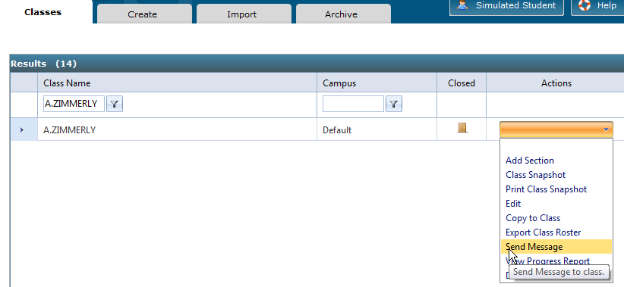
- Click Send Message to open the Message Center, Create tab.
- Note that the Class name has been inserted in the To User box automatically—no searching required.
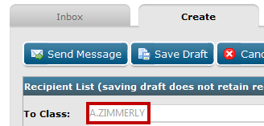

To send a message from the Message Center, Create tab:
- From the Message Center, Create tab, under Recipient List, click the green plus sign at the end of the To Class box.
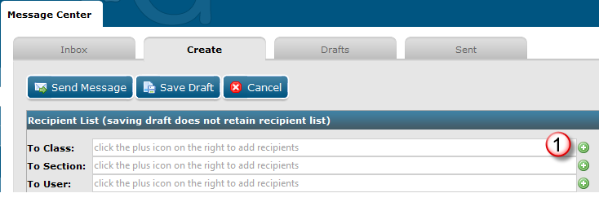

- From the Send to Class dialog box, click the desired Class.
- Click Add Recipients to return to the Create tab.
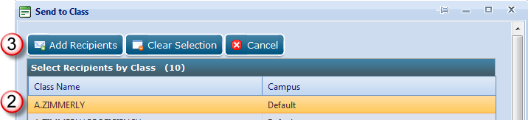

- Note that the Class name now appears in the To Class box.
- Type a subject and message and format as desired.
- Check or uncheck Allow student to reply to message as desired.
- Click Send Message when you’re done.
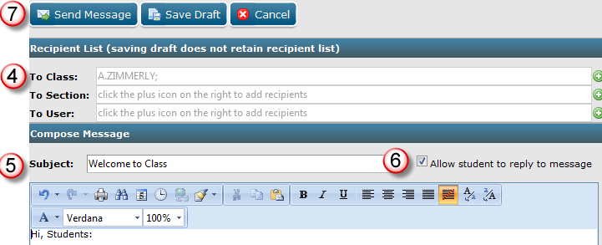

To create and send a message to a Section:
You can use the Message Center, Create tab, to broadcast a message to a Section; but you’ll need to search for the Section when you click Add Recipient from the To Section box. Using the Classes tab, Sections Actions menu, to broadcast a message to class is seamless. Follow the same steps for sending a message to a Section, except:

- From the Classes tab, you will use the Actions menu for the desired Section
- From the Message Center, Create tab, you will use the To Section box and select a Section rather than a Class.

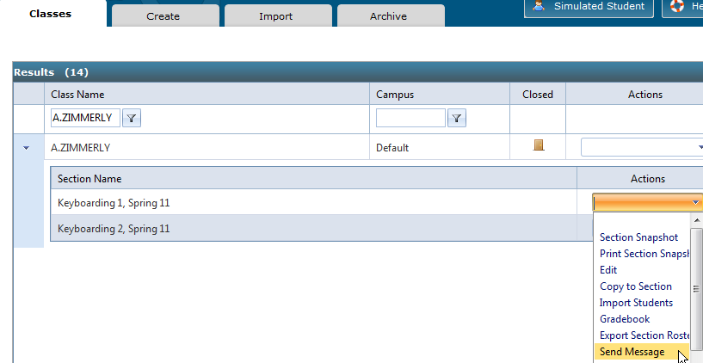
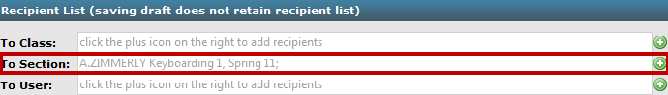

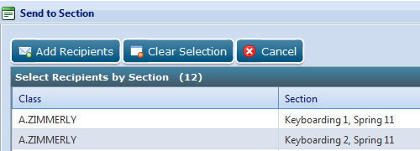

To create and send a message to a User (student):
You can use the Message Center, Create tab, to send a message to a student; but you’ll need to search for the student when you click Add Recipient from the To User box. Using the Student tab to send a message to an individual student is seamless.

To send a message from the Students tab:
- From USERS, Students, Students tab, click the Actions menu for the desired student.
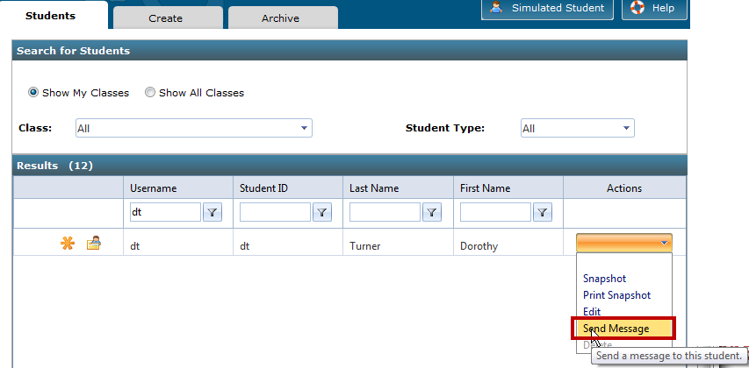
- Click Send Message to open the Message Center, Create tab.
- Note that the student’s name has been inserted in the To User box automatically—no searching required.
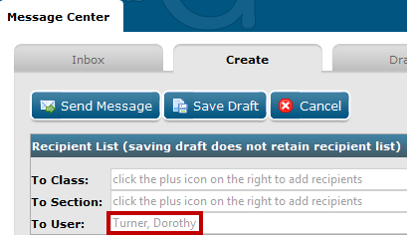

To send a message from the Message Center, Create tab:
- From the Message Center, Create tab, under Recipient List, click the green plus sign at the end of the To User box.
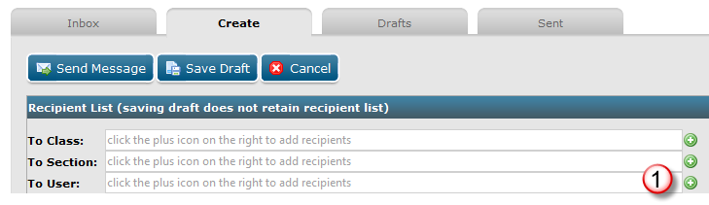

- From the Send to User dialog box, under Search, type any relevant information in any of these boxes: Student ID, First Name, User Name, and/or Last Name.
- Click Search until your search returns the desired student name in the Results pane.
- From the Results pane, click the desired recipient(s).
- Click Add Selected Recipients to move that recipient name into the Selected Recipients pane at the top. Continue in like manner until all recipients are added.
- Click Add Recipients to close the Send to User dialog box and return to the Create tab.
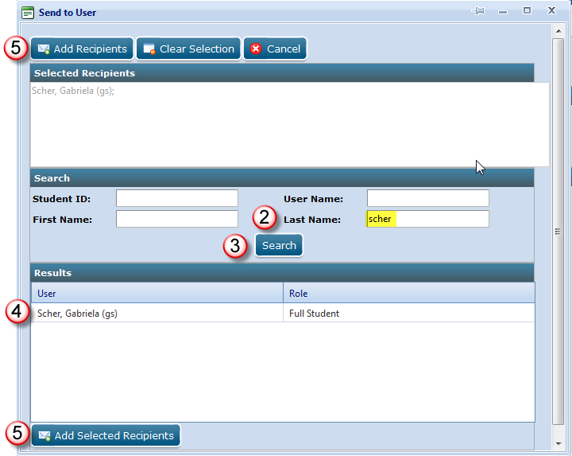

- Note that the recipient name now appears in the To User box.

To clear Recipients:
- From the Message Center, Create tab (or any dialog box in which a Recipient List is present), under Recipient List, click the Add Recipient button (green plus sign).
- From the Send to Class, Send to Section, or Send to User dialog box, click the Clear Selection button.
- Click Add Recipients.
- Note that all recipients are cleared from the To Class, To Section, or To User boxes.

MESSAGE CENTER—STUDENT

To open the Message Center:
From My GDP, click Message Center. When a new message arrives, students will see a red number by MY GDP and by Message Center and an icon under the New column. 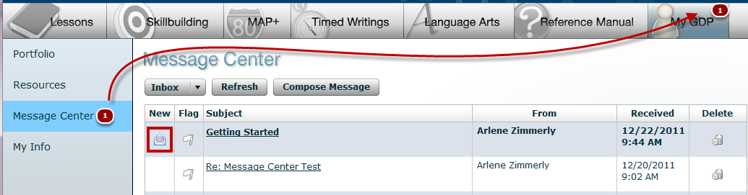

The Inbox, Drafts, and Sent features are accessed via a drop-down menu.
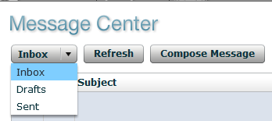

Inbox
Inbox displays a list of incoming messages. Unread messages display in bold. Click the Flag to flag this item, click the message line to open and read the message, and click Delete to delete the message.
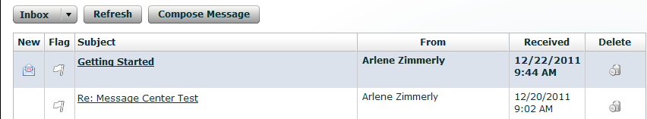

Draft
Draft displays a list of message drafts. Click the Flag to flag this item, click the message line to open and read the message, and click Delete to delete the message.
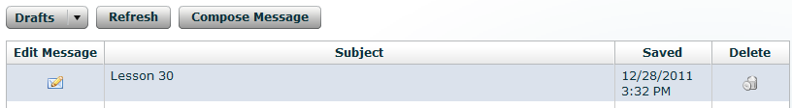

Sent
Sent displays a list of sent messages.
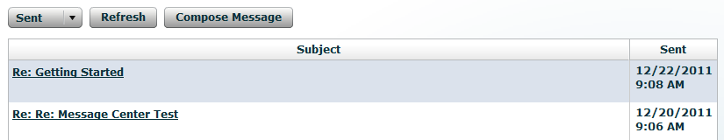

Refresh
Click Refresh to refresh the screen and display any new messages since the student last logged on to GDP.

Compose Message
- Click Compose Message to display the Compose Message window.
- Click the green plus sign by the To box to open the Select Recipients window.
- From the Select Recipients window, check the box(es) next to the desired recipient(s). (The list of recipients will vary.)
- Click Add/Remove Recipients.
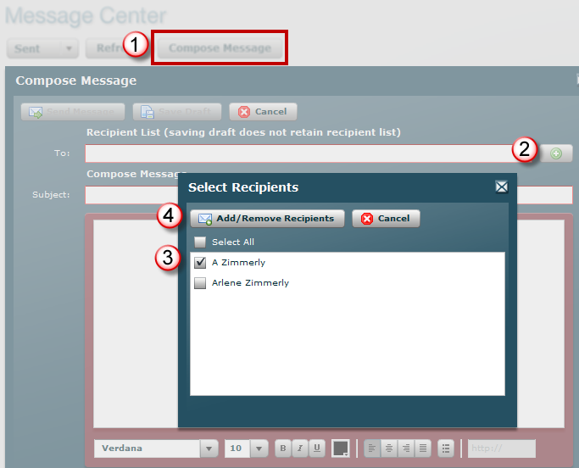

- Type a subject and message and click Send Message.
