Week 1 Announcements

ORIENTATION TO KEYBOARDING ONLINE AND GDP: Congratulations to all of you who attended orientation. You’re off to a great start. If you missed it, click here to view a summary. Be sure you have submitted the Questionnaire or I will not be able to contact you!

LESSONS 1-5: Click the “LESSONS 1-5” link at the left to open a PDF file for Lessons 1-5. You may duplicate this file for use until you purchase your textbook. Or you can open it electronically and arrange and resize your GDP window and the Lessons window as shown below so you can complete Lessons 1-5.

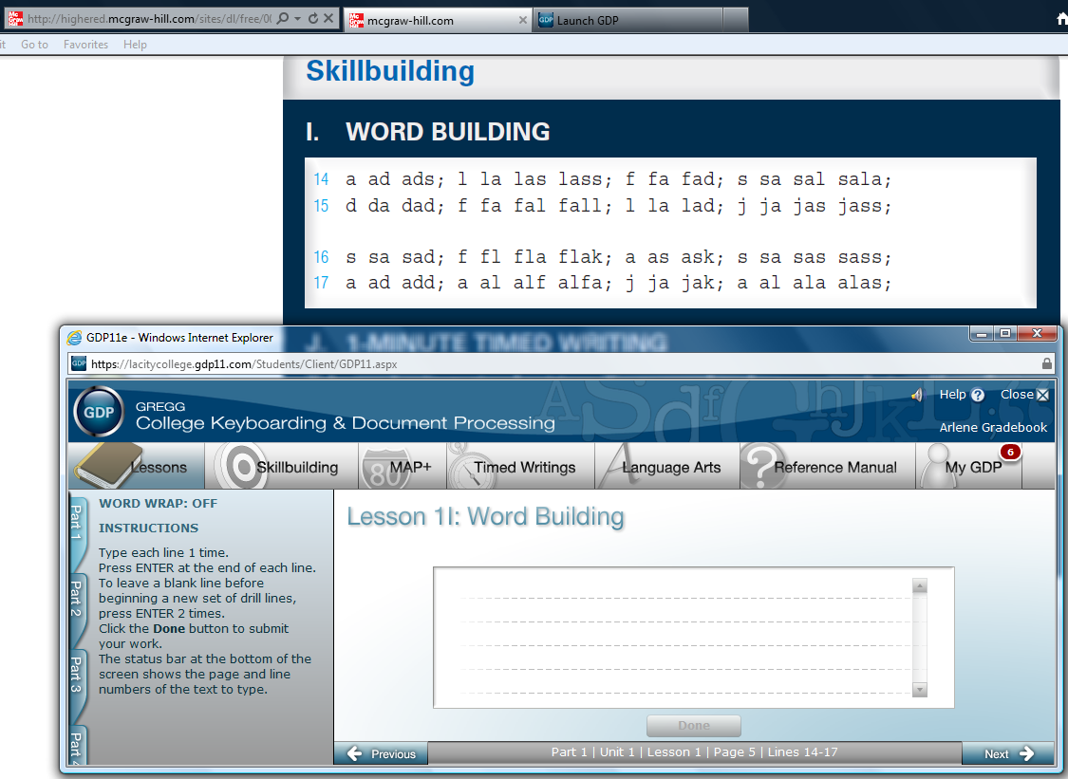
WEEK 1 ASSIGNMENTS: I allow a grace period of three weeks at the start of the semester before I penalize late work to give you time to settle in to the routine of an online course. Due dates will be enforced beginning Week 4. Your goal this week is to complete Lessons 1-2. Send me a message via My GDP, Message Center, when you have submitted work.

It is critical to your success to keep on schedule from the first week forward. Not reading your weekly Assignment sheet and not completing your work by the end of the week is like being absent in a traditional class. Check the Week 1 assignment link to view all assignments. I'm looking forward to those e-mail messages telling me I have new work from you! Have a wonderful weekend!

Professor Arlene Zimmerly

